 | Adult/Adolescent  Outpatient/IOP and ADSAP  Patient Handbook



Human Services Building | 1905 Duke Street, Suite 270 | Beaufort, SC 29902 | 843.255.6000
Bluffton Government Center | 4819 Bluffton Parkway, Suite 303 | Bluffton, SC 29910 | 843.255.6020

Table of Contents

Philosophy Page 2
Welcome Page 3
Patient C.A.R.E Team Page 3
Ethical/Professional Expectations of Counseling Staff Page 3
Accessibility Page 4
Hours of Operation Page 4
Parking Page 4
Financial Responsibilities Page 4
Consent to Treatment Page 5
Consent to Release Information Page 5
Confidentiality Page 5
Your Assessment: Purpose and Process Page 6
Individualized Plan of Care (IPOC), Goal Development
And Achievement Page 6
Course of Treatment/Types of Services Page 6
Transition/Discharge Criteria and Procedures Page 7
Urine Drug Screens Page 7
Pharmacotherapy Statement Page 7
Department Health and Safety Policies Page 7 Staff Responses to Risk Page 8
Patient Complaint and Appeal Process Page 8
Providing Feedback Page 9
Motivational Incentives Page 9
Family Involvement Page 9
Expectations for Legally Required Appointments, Sanctions, Court Notifications Page 9
Patient Refunds Page 9 Rights and Responsibilities of Patient Page 10
Behavioral Expectations of Patient Page 12
Appendix:
Fee Schedule Page 14
Online Credit Card Payment Directions Page 15

Philosophy of Nexus Care of Beaufort County

In pursuing its mission, Nexus Care of Beaufort County holds these tenets and beliefs:

- Misuse of alcohol, drugs, and tobacco impacts negatively on the quality of life of the entire community through health costs, accidents, child and spouse abuse, and crime, work, and school performance. It is believed that the most effective approach to reducing the negative impact is to use a Recovery Oriented System of Care approach to recovery.

- Addiction is a disease, not a moral weakness, and people affected by the disease should be treated with dignity and respect.

- The whole person needs to be treated, which involves the family and works toward maximizing the person's physical, mental, emotional, and spiritual well-being.

- Using a variety of strategies, high-risk behaviors can be identified and reduced, as can substance use. Addressing substance use will decrease high-risk behaviors. Nexus Care of Beaufort County is committed to providing resources and evidence-based approaches.

- There should be no barriers to treatment. We strive to remove architectural, attitudinal, childcare, employment, financial, transportation, and other barriers for all people served. Services should be provided where patients are identified.

- Treatment should be provided regardless of a person's age, gender, race, creed, national origin, sexual orientation, or socio-economic status. Treatment will be offered regardless of a patient’s ability to pay for services.

- Those affected by addiction can best be helped by a team of highly qualified professionals with experience in addiction treatment. People affected by addiction are ultimately responsible for their recovery and actively participate in their treatment planning and recovery process. Furthermore, the Twelve-Step Recovery Program and other forms of mutual support are vital for the patient's recovery.

Welcome to Nexus Care of Beaufort County

The Adult Outpatient Continuum of Care includes two distinct areas of service: Traditional Outpatient services, which treat patients at a Level I ASAM level (group, individual, and family counseling less than nine contact hours per week), and Intensive Outpatient services, which provide patients with Level II.1 ASAM level (nine hours or more of services per week).

Adolescent Services offers Level I ASAM-level services to adolescents, their families, and identified caretakers in weekly group, individual, or family counseling for less than six hours.

ADSAP is a court Diversion Program that is curriculum-based unless the patient demonstrates the need for a higher level of care through the primary assessment or repeat offense of a Driving Under the Influence conviction (DUI).

The specifics for each of the above programs, including goals, program descriptions, hours of service, admission criteria, and other specific program issues, are addressed below.

Intensive Outpatient Treatment meets at least nine hours weekly to provide substance abuse education and counseling, coping skills development, support and symptom management (formerly known as relapse prevention) counseling, and individual and/or group counseling.

Traditional Outpatient Groups are developed to serve patients' various needs. They are either process-oriented or skills-based, and placement in one or both groups is based on your assessed needs and mutually agreed-upon treatment goals.

Mission: Our mission is to reduce the negative impact of alcohol and drugs in Beaufort County by providing its citizens with trauma-informed prevention, intervention, treatment, and recovery services.

Goals for each program:
- Sobriety or reduced risk of substance misuse
- Improved functioning biopsychosocially

Thank you for allowing Nexus Care of Beaufort County the opportunity to serve you.

Patient C.A.R.E Team

You will be assigned a primary counselor who will oversee your treatment during your time here. Counselors, Peer Support Specialists, and Clinical Supervisors are the Compassionate Alliance for Recovery Empowerment (C.A.R.E.) team. You will be given an appointment to meet with your counselor during screening. Your counselor will coordinate all your care and make any referrals necessary for concurrent care. You may also have additional services provided by other counselors; however, your primary counselor will be your main contact for person-centered treatment planning, transition planning, referrals for other services or case management, and discharge planning.

If not eligible for services, based upon the screening or assessment, the assigned counselor will provide all necessary and legally permissible notifications and recommend other services through information provision or referral, as applicable.

Ethical/Professional Expectations of Counseling Staff

Individuals seeking services from the Nexus Care of Beaufort County will not be discriminated against based on race, religion, language group, age, gender, disability, sexual orientation, or economic condition. Nexus Care of Beaufort County staff understands their responsibility to patients, confidentiality, professional competence and integrity, financial arrangements, and inter-professional relationships. They are dedicated to respecting the rights of the people served and will work to ensure that services are accessible and appropriate. Staff will respect and protect the confidences of patients in accordance with federal law and will make financial arrangements with patients and third-party payers that conform to acceptable professional practices. You can expect a high standard of professional competency and integrity, professional boundaries and limitations of competencies, and to treat patients with respect, courtesy, and fairness.

Accessibility

Nexus Care of Beaufort County promotes accessibility of services to all residents of Beaufort County regardless of race, religion, gender, ethnicity, age, handicap, sexual orientation, or ability to pay for services. Nexus Care of Beaufort County is committed to ongoing efforts to remove biases and barriers, including attitudinal barriers. Reasonable accommodation ensures that the services and facilities are accessible to all patients, visitors, staff, and other stakeholders.

- Patients and visitors requiring service animals, such as seeing-eye dogs, will be permitted on Nexus Care of Beaufort County premises.

- Patients in need of services not provided by Nexus Care of Beaufort County or patients determined to be ineligible for services will be provided with referrals to appropriate services with as much accommodation as possible.

- Patients will not be denied services based on their inability to pay. If the ability to pay is an issue, special financial arrangements will be made.

- Nexus Care of Beaufort County is committed to developing and providing reasonable accommodation for people needing communication assistance. Reasonable accommodations include but are not limited to arranging for and providing interpreters for the hearing impaired, providing tapes and materials in Braille or reading to the visually impaired, providing tapes and alternative materials for the cognitively impaired, and arranging a change in service location.

Foreign language interpreters and materials will be utilized to provide services/information to those patients/visitors who do not speak English.

Hours of Operation

Nexus Care of Beaufort County’s ADSAP Program operates between 8:00 a.m. and 5:00 p.m. Monday Through Friday, though group services are offered Monday through Thursday until 7:30 pm. and on Saturdays. Counselors work various hours, so check with your primary counselor about any individual needs you may have. Each counselor has a confidential voicemail where you may leave a message anytime. A counselor will return your call as soon as possible.

Scheduled appointments are preferred for all the department services. However, if a counselor is available, walk-in patients will be seen.

Nexus Care of Beaufort County recommends that patients in crisis or having emergencies call 911 or go to the Beaufort County Emergency Room, especially outside of hours of operation.

Financial Responsibilities (Please see attached fee schedule.)

As a patient, you are responsible for ensuring that the financial obligations of your healthcare are fulfilled as promptly as possible. Further charges will be incurred if you are referred to any services beyond the Prime for Life curriculum. You are responsible for paying for charges more than those covered by the registration fee paid at intake. If necessary, speak with your counselor about completing a financial assessment and/or setting up a payment plan.

Consent to Treatment

No patient may participate in Nexus Care of Beaufort County treatment services without having consented to do so. As such, all patients are offered a document wherein it is identified that Nexus Care of Beaufort County “intends” to provide them with treatment services and, if you agree, that you have “consented” to it. Nexus Care of Beaufort County may not compel you to engage in services, though you may have been obligated to do so by an external supervising department or referral source (DSS, PPP, SCDC, etc.). Any consequences for failing to engage services or for a pre-mature administrative discharge would emanate from that department, not Nexus Care of Beaufort County.

Consent to Release Information

As identified in the Confidentiality Policy section below, without your written consent:

“Nexus Care of Beaufort County may not say to a person outside Nexus Care of Beaufort County that you attend the program, nor may Nexus Care of Beaufort County disclose any information identifying you as an alcohol or drug abuser or disclose any other protected information except as permitted by federal law.”

At admission or during your treatment, you may need to complete Consent forms with a staff member if you wish for us to communicate with your referral or supervising department (DSS, PPP, SCDC, etc.). In addition, if you wish for us to be able to communicate with members of your family, friends, etc., you must also complete a consent form.

Nexus Care of Beaufort County cannot require that you complete a consent form for a specific department, but those same agencies may often require that you do so to communicate with your counselor. Please check with your referral/supervising department to confirm your responsibilities with them regarding consent forms.

Confidentiality

Your Privacy
General Information regarding your health care, including payment for health care, is protected by two federal laws: the Health Insurance Portability and Accountability Act of 1996 ("HIPAA "), 42 U.S.C. § 1320d et seq., 45 C.F.R. Parts 160 & 164, and the Confidentiality Law, 42 U.S.C. § 290dd-2, 42 C.F.R. Part 2. Under these laws, Nexus Care of Beaufort County may not say to a person outside Nexus Care of Beaufort County that you attend the program, nor may Nexus Care of Beaufort County disclose any information identifying you as an alcohol or drug abuser or disclose any other protected information except as permitted by federal law.

Nexus Care of Beaufort County must obtain your written consent before disclosing information about you for payment purposes. For example, Nexus Care of Beaufort County must obtain your written consent before disclosing information to your health insurer to be paid for services. Generally, you must also sign a written consent before Nexus Care of Beaufort County can share information for treatment purposes or health care operations. However, federal law permits Nexus Care of Beaufort County to disclose information without your written permission:
1. Under an agreement with a business associate.
2. For research, audit, or evaluations.
3. To report a crime committed on Nexus Care of Beaufort County's premises or against Nexus Care of Beaufort County personnel.
4. To medical personnel in a medical emergency.
5. To appropriate authorities to report suspected child abuse or neglect
6. As allowed by a court order

For example, Nexus Care of Beaufort County can disclose information without your consent to obtain legal or financial services or to another medical facility to provide health care to you if there is a business associate agreement in place. Before Nexus Care of Beaufort County can use or disclose any information about your health in a manner not described above, it must first obtain your specific written consent allowing it to make the disclosure. You may revoke any such written consent in writing.

Your Rights
Under HIPAA, you can request restrictions on certain uses and disclosures of your health information. Nexus Care of Beaufort County is not required to agree to any restrictions you request, but if it does agree, it will be bound by that agreement. It may not use or disclose any information you have restricted except as necessary in a medical emergency. You have the right to request that we communicate with you by alternative means or at an alternative location. The Nexus Care of Beaufort County will accommodate reasonable requests and will not request an explanation from you. Under HIPAA, you also have the right to inspect and copy your health information maintained by Nexus Care of Beaufort County, except to the extent that the information contains psychotherapy notes or information compiled for use in a civil, criminal, or administrative proceeding or other limited circumstances.

Confidentiality (continued)
Your Rights (continued)
Under HIPAA, you also have the right, with some exceptions, to amend health care information maintained in Nexus Care of Beaufort County’s records and to request and receive an accounting of disclosures of your health-related information made during the six years before your request. You also have the right to limit sharing if you pay out of pocket, opt out of fundraising activities, and receive a paper copy of this notice. HIPPA prohibits the use or disclosure of genetic information and the sale of your PHI.

Nexus Care of Beaufort County's Duties
Nexus Care of Beaufort County is required by law to maintain the privacy of your health information and to provide you with notice of its legal duties and privacy practices concerning your health information. Nexus Care of Beaufort County is required by law to abide by the terms of this notice. Nexus Care of Beaufort County reserves the right to change this notice's terms and make new notice provisions effective for all protected health information it maintains. You will receive a copy of this notice at intake or upon request.

Complaints and Reporting Violations
You may complain to Nexus Care of Beaufort County and the Secretary of the United States Department of Health and Human Services if you believe your privacy rights have been violated under HIPAA. Your complaint must be in writing and sent to the Privacy Officer, Nexus Care of Beaufort County, 1905 Duke Street, Beaufort, SC 29902. You will not be retaliated against for filing such a complaint. Violation of the Confidentiality Law by a program is a crime. Suspected violations of the Confidentiality Law may be reported to the United States Attorney in the district where the violation occurs. Contact the Privacy Officer at (843) 255-6006 for further information.

Assessment: Purpose and Process

Every patient engaged in alcohol and other drug (AOD) treatment services at the Nexus Care of Beaufort County must have participated in an assessment. Patients in Outpatient, Intensive Outpatient Services, Adolescent Services, ADSAP, or Therapeutic Behavior Services engage in this process before admission. A counselor will assess the patient. The assessment consists of numerous questions aimed at helping the clinician accurately determine a patient’s service needs and what level of care would be most appropriate. It is very important to this process and to each patient’s care that they answer all questions as honestly and accurately as possible so that clinical decisions are based on correct information. This process can last up to 2 hours.

Individual Plans of Care (IPOC), Goal Development and Achievement

All patients participating in AOD treatment services will work with their assigned counselor to develop an Individual Plan of Care (IPOC). Patient input in this process is integral as we work diligently to ensure that all treatment plans are “individualized.” Patients are encouraged to be active participants in developing their IPOC and subsequent IPOC reviews. Within each IPOC are specific goals patients are working toward achieving; treatment goals are mutually discussed and agreed upon by the clinician and patient and are based on patient needs and desires. Each IPOC goal also possesses measurable objectives, actions, and interventions to ensure that a patient’s goal achievement is readily identifiable.

Patients assigned to PRI Group (Diversion Service) will not have a Treatment Plan.

Course of Treatment/Types of Services

Upon entering services, we will recommend the least intensive service we think will help you be successful. If alcohol or other drug use continues, more problems occur, or the treatment doesn’t seem to be working, we may recommend more intensive levels of care.

Types of Services Offered:
- Prime for Life Alcohol and Drug Education Group (PRI): Meets 2 days per week for 2 hours per group session.
- Adolescent Services under 6 hours weekly.
- Outpatient: Services total less than 9 hours weekly.
- Intensive Outpatient (IOP) Group: Services must total at least nine hours weekly.
- Peer Recovery Support Services, Group or Individual.

Course of Treatment/Types of Services (continued)

Every patient’s needs are unique to themselves and their life circumstances. As such, each patient's course of treatment and related services may vary greatly. Of certainty is that treatment services are based upon a patient’s progress toward the mutually agreed upon goals established in the IPOC. Treatment experiences are generally not time limited. Patients should engage in conversation with their counselor regarding their course of treatment.

NOTE: Treatment for patients in ADSAP may not exceed 1 year as established in legislation.

Transition/Discharge Criteria and Procedures

Patients are discharged or transitioned from treatment services after the following:

- Meet ASAM PPC-II Discharge Criteria to be successfully transitioned.
- Withdraw from services voluntarily.
- Fail to comply with program requirements – consistent rule violations, not adhering to attendance requirements, etc.
- Referral of transfer to another level of care or program is required to meet their clinical needs better.

All decisions to discharge/transfer are “staffed” and documented by the Treatment Team before implementation and thus are Team decisions. If you disagree with a Treatment Team decision, please adhere to the Complaint Process outlined above.

Patients are discharged or transitioned from education/intervention services after the following:

- Successfully attend the number of groups they have been assigned.
- Complete any exit documentation required.

Urine Drug Screening

Urine drug Screenings (UDS) are conducted randomly in all services to aid treatment. They are a requirement to participate in our services, and refusal to give a specimen when asked will result in a report of a positive result for drugs. Specimen will only be observed by a same-sex staff member. This can be uncomfortable initially, and if you have concerns, please speak to your counselor. Urine Drug Screening is a part of your treatment but is intended to be respectfully conducted and not punitive.
- Testing may not be done at every session, but you should be prepared to provide a specimen if requested.
- It is much better to tell your counselor if your specimen may be positive for drugs before it is given than to admit use after the results have come back.
- Any attempt to hide or fake a UDS may result in discharge from services.
- When allowed with release forms, UDS results will be reported to referral sources.
- The prevailing use of this department will be for treatment considerations.

Pharmacotherapy Statement

Medications are an important treatment element for many patients, especially when combined with counseling and other behavioral therapies. We are concerned about the possible interactions and effects that many legal and illegal drugs and/or substances may have on you and your recovery; therefore, you may be asked to voluntarily sign consent to release information so that we can talk to any doctor who may be prescribing a medication to you or with whom we may want to have a consultation. We believe both behavioral treatments and medications can be critically important to sobriety. Your cooperation and openness would be appreciated and helpful to your recovery.

Department Health and Safety Policies

Legal/Illegal/Prescription and OTC Substances Brought into the Program

Please refrain from bringing legal or illegal substances into the building (alcohol, narcotics, “synthetic” substances, etc.). Doing so may lead to your discharge from the program. Prescription medications other than nitroglycerin and Epee Pens are not to be brought into the building. If you are prescribed medication that you must have in your possession, please make your counselor aware.

Department Health and Safety Policies (continued)

Orientation to the Building (including emergency exits& Emergency Protocols)
During your admission, a staff member will show you the location of the fire exits and where fire alarm pull stations are located. Staff will also show you the location of bathrooms, offices, group rooms, etc. Copies of emergency procedures are posted on the bulletin board, and patients will receive copies of emergency protocols. Patients must participate in drills. Essentially, during any drill, patients (visitors) are to follow the directions of staff, exit where guided, if applicable, or follow any other protocol posted and directed. Failure to participate in drills may result in program termination.

Evacuation Procedures
During your Nexus Care of Beaufort County experience, you may hear a loud fire bell accompanied by strobe lighting. This is a signal to evacuate the building as directed by staff. Please leave whichever room you are in and follow the direction of the staff member who will direct you to the closest, safest exit. Move quickly down the stairwell, stay with a staff member, and remain outside the building in the designated area instructed by staff until you are told it is safe to return.

Use of Seclusion/Restraint
Nexus Care of Beaufort County does not believe in the use of seclusion or restraints (drug-induced or physical) during admission to our services.

Use of Tobacco Products
Nexus Care of Beaufort County promotes active recovery for people whose lives are affected by addiction. In addition to known health risks, some research links the use of tobacco products with alcohol and other drug addictions. Smoking in the Nexus Care of Beaufort County building or on the property is prohibited.

E-cigarettes are included in this policy.

Weapons Brought into the Program
Please refrain from bringing any weapon into the facility. Doing so may lead to your discharge from the program.

Staff Response to Potential Risks

Nexus Care of Beaufort County Staff will adhere to department-specific Emergency Response Procedures for managing risks (weather-related, fire-related, violence-related, evacuations, etc.).

As Mandated Reporters, staff are required to contact the Department of Social Services if they become aware of any child or elderly abuse. This can be done without your consent.

In addition, if a patient/patient presents himself/herself as a danger to themselves or others, staff will contact the police. This, too, can be done without your consent.

In terms of suicide, staff will work with any patient experiencing suicidal thoughts to develop a Crisis Prevention and Intervention Plan (Safety Action Plan) designed to improve their recognition of signs of suicide as well as resources available to support them during times of need. Department policy is that one is required for anyone expressing or thinking about self-injurious thoughts within the last 90 days.

Patient Complaint and Appeal Process

Nexus Care of Beaufort County is concerned about your satisfaction. Please let us know if you have a complaint about your treatment or the services provided. We will respond to your complaint as soon as possible.

- Make a complaint or discuss an appeal with your Counselor or The Treatment Director. If a satisfactory resolution is not agreed upon within 5 days, then proceed to #2

- The Patient will be allowed to meet with the Treatment Team. If a satisfactory resolution is not agreed upon within 5 days, then proceed to #3

- The Patient will be offered a meeting with The Director and the Treatment Director to discuss all proposed resolutions and the Patient’s resolution preference. The Director will review any written complaints and documentation from Steps 1 and 2 before the meeting with the Patient. During or within 5 days of this meeting, a final resolution from this agency level will be rendered and provided to the patient in writing.

The identified Patient or the parent/legal guardian of a minor under 16 is responsible for making a complaint or appealing any decision.

Patients are always advised to work through the chain of command unless the complaint is related to someone within the chain of command. In those instances, contacting the Treatment Director or the Director may be more appropriate. However, if not appropriate, the complainant will be redirected to work through the chain of command:

Areatha Hamilton | Treatment Director | 843-255-6006
Rebecca Whitt | Director | 843-255-6008

If not satisfied with the resolutions, the following authorities may be contacted:

SC Office of Substance Use Services | 803-896-5555
SC Department of Public Health | 803-545-4458

Providing Feedback

At Nexus Care of Beaufort County, we are always open to any ideas or suggestions that may allow us to improve our services. If you come up with an idea or suggestion, you may take one of the following steps:

- Share with your counselor.
- Contact any of the staff members identified above.
- Complete our survey at https://www.surveymonkey.com/r/CH98XTD at any time. Responses are posted quarterly from patient feedback.

Motivational Incentives

Motivational incentives are not incorporated into your treatment program. However, we acknowledge progress and support the well-being of all patients.

Family Involvement
We believe that substance abuse is a problem for the whole family, so all our services include ways for your family to be involved as well as you. When families get involved, treatment is more successful, and family relationships are more likely to improve. Without family participation, you are less likely to succeed in treatment and more likely to have more problems later; therefore, regular involvement in services by at least one parent, grandparent, other relative, or legal guardian is a requirement of all our services. If a family thinks this may be a problem, they should discuss it as early as possible with the primary counselor.

Expectations for Legally Required Appointments, Sanctions, Court Notifications

Occasionally, patients are required to attend services through a court or another department. In those cases, counselors must notify your referral source of your progress and participation in treatment. Though this can be uncomfortable for you and may result in consequences from your referral source, it is important to remember that we represent your interests only, except in circumstances where public safety concerns.

As mentioned earlier, Nexus Care of Beaufort County cannot require you to complete a consent form for a particular department. However, the department you’re referring to or the supervising department may require you to complete a consent form.

Patient Refunds

Patient refunds will be pro-rated by the length of time spent in services.

Each patient seeking a refund must submit a written request to the ADSAP Program Administrator. Once the request has been received and approved, a refund will be forwarded to the patient’s mailing address within 30 business days.

Rights and Responsibilities of Patient

Patient Rights

- To be entitled to respect and dignity in an environment that affords security and privacy.

- To receive services protected under the laws of confidentiality and to receive a Privacy Notice as well as other information concerning your rights regarding the use, storage, and disclosure of healthcare information.

- To receive services regardless of race, sex, national origin, creed, physical or mental handicap, or personal ability to pay.

4. To know the reasons for or purpose of the services provided and to consent to receiving these services.

5. To receive an individual evaluation and treatment based on your needs, abilities, and goals, including your active participation in the development of your plan of care.

6. To ensure that your needs and preferences are not neglected and to receive any information needed to make informed decisions concerning the services you receive.

- fees to be assessed on an equitable basis.

- To express your preferences concerning the case manager, counselor, or other service provider choice.

- To review your records upon reasonable request and as provided by law.

- To refuse treatment or withdraw from services at any time without affecting re-entry at a later time. *

- To be free from physical abuse, sexual abuse, harassment, and physical punishment imposed by program employees.

- To be free from psychological abuse, including humiliating, threatening, and exploitative action on the part of program employees.

- To be free from fiduciary abuse associated with program employees holding in trust anything of value that belongs to you.

- To be informed of and treated in compliance with the department’s policy on seclusion, restraint, special treatment interventions, and the restriction of rights.

- To receive assistance from the program in facilitating access and referral to guardians, conservators, self-help groups, advocacy, and legal services; and

16. To have privacy during visits unless contraindicated in the recovery and treatment process or as requested by a physician or other authorized healthcare provider.

- To have an investigation done on your behalf whenever you believe one of your rights has been violated.

- To have your property treated and handled responsibly and with respect.

Rights and Responsibilities of Patient (continued)

Patient Responsibilities

- Providing Information:
To the best of your knowledge, you are responsible for providing accurate and complete information about current medications, past illnesses and hospitalizations, any medications you are taking, medication allergies, and other matters relating to your health. You are responsible for reporting unexpected changes in your condition to your health practitioner.

- Refusal of Treatment:
If you refuse treatment or do not follow the counselor's instructions, you are responsible for any consequences from your referral source or supervising department.

- Treatment Plan:
You are expected to participate in the development of your treatment plan.

- Financial Charges:
As a patient, you are responsible for ensuring that your healthcare financial obligations are fulfilled as promptly as possible.

- Attendance:
Patients other than ADSAP PRI are expected to attend at least 85% of all scheduled group and/or individual therapy sessions. PRI Patients must attend 100% of sessions to complete services. Patients are to call the primary counselor whenever an absence occurs. Patients are also expected to be punctual.

- Dress Code:
Patients must be appropriately always dressed to include:
- Supportive undergarments must be worn (bras and underwear).
- Shoes must always be worn.
- No attire promoting alcohol, drugs, or cultural or racial bias will be worn.
- No provocative clothing will be acceptable.
- No sunglasses or hats to be worn while in the building.

Definitions:
Conservator- keeper
Contraindicated- not advised
Creed- A statement of faith
Exploitive- make use of
Equitable- fair and reasonable
Fiduciary- trust

*Note: Withdrawal from participation in some programs may delay your re-admission to services. If your participation in this program results from involvement with the criminal justice system, your legal status may be jeopardized by withdrawal without court, probation, or parole permission. Please make certain of your situation before withdrawing.

Behavioral Expectations of the Patient

Respect and Consideration

You are responsible for considering the rights of other patients and Nexus Care of Beaufort County personnel. You must assist in controlling noise and honoring our smoke-free environment. You are responsible for being respectful of the property of others and Nexus Care of Beaufort County. We have ZERO tolerance for inappropriate language, which includes threats of harm towards staff and peers, profanity, and any form of racial, ethnic, or sexual orientation slurs. In addition, please adhere to the following:

- Any violence or threats of violence
- Criminal behavior
- Bringing or possessing alcohol, illegal drugs, non-prescribed medications, or weapons on the premises
- Selling or distributing drugs to others on premises
- Consistently wearing attire promoting alcohol, drugs, cultural or racial bias.
- Disrespect of staff and or other patients by using obscene language
- Failure to comply with treatment expectations
- Failure to respect the personal space of others
- Consistent rule violations
- Attempting to adulterate a drug screen specimen/bringing someone else’s urine for testing
- Attending less than 85% of scheduled services - IOP/Outpatient/ ADSAP 100%
- Consistently late to appointments

Note: Engaging in these behaviors could lead to an immediate Administrative Discharge from services.

Other Behavioral Expectations
- Dress code (see above in “Patient Responsibilities”)
- Electronic Devices: Anything with an on or off switch must be in the off position when outpatient counseling sessions start (examples: cell phones, iPods, etc.) If they are heard during a session, the counselor will hold them until the end of the session.
- Cameras/Photography: Patients may not take photos on facility grounds.
- Patients reserve the right to have money; however, you are strongly discouraged from keeping large sums of money or valuables in your possession. Nexus Care of Beaufort County is not responsible if money or valuables are stolen.
- Pairing off, hooking up, or any sexual relations between patients is highly discouraged.

Fee Schedule Effective December 1, 2025
Services | Fee Per Service
Behavioral Health Screening (15 to 30 minutes) | $35.00
Diagnostic Assessment | $200.00
Follow-Up Assessment | $110.00
Service Plan Development with Patient Present | $65.00
Service Plan Development without Patient Present | $40.00
Individual Therapy – 30 Minutes | $75.00
Individual Therapy – 45 Minutes | $115.00
Individual Therapy- 1 hour | $150.00
Family Psychotherapy with or without the patient-60 minutes | $160.00
Group/Multiple Family Group Therapy-60 minutes | $115.00
Substance Use Counseling-Group | $110.00 per hour
Substance Use Counseling – Individual | $110.00 per hour
Family Support Services | $60.00 per hour
Intensive Outpatient | $60 per hour
Crisis Management 15 to 30 minutes minimum, up to 60 minutes | $155.00 in-person; $115.00 phone/virtual
Peer Recovery Support Services – Individual per 15-minute unit | $15.00
Peer Recovery Support (Aftercare) Group (one hour) | $50.00
Psychosocial Rehabilitation Services Group- Individual 15-minute unit | $15.00
Psychosocial Rehabilitation Services Group-60 minutes | $50.00
Broken Appointment without a 24-hour notice of cancellation | $25.00

Medical Services | Fee Per Service
UDS are included in package programs, like ScIP and OBI.  UDS sent to the laboratory are the patient’s responsibility. Millennium has indigent applications and accepts insurance. Self-pay patients’ insurance patients with deductibles will receive a bill directly from Millennium. | $60 fee directly with Millennium per UDS  (Not to Nexus Care)
Breathalyzer (alcohol screening) | $15.00

Miscellaneous Fees
Medical Record Copy Fee | $12.00 up to 10 Pages (.65 cents per page, up to 30 pages) $0.50 per page thereafter. $6.50 flat fee for electronic release.
Returned Check Fee | $30.00
Paperwork Fee | $15.00 per 15 minutes

Packaged Program Service | Total Fee
ADSAP Education Group (Prime for Life for DUI)  ADSAP Treatment Service | $500.00 +15. Per UDS (Typically x2)  Fee per hour: see above rates
Offender-Based Intervention (OBI)  Alcohol & Drug Awareness Program (AEP)  Transfer of Beer (PREP) | $150.00  $125.00  $50.00
SAP (Department of Transportation) No cap on total fees for clinical services | $350 assessment to be paid at the time of evaluation. All clinical services (excluding UDS) are regular rates.

Fees for the ADSAP Program are set by OSUS and the SC Code of Laws. The cost for ADSAP is to be paid prior to completion of ADSAP and eligibility to regain driving privileges. No paperwork for completion will be sent to SCDPS through OSUS until all fees are paid. Fees for ADSAP Treatment do not exceed $2,500. *SAP is not completed until all fees for services are paid in full.

Nexus Care of Beaufort County ADSAP Fee Policy

OSUS and the SC Code of Laws set the fees for ADSAP. The cost for ADSAP services shall not exceed:
- ^{$75 Basic Test/Assessment}
- ^{$160 Full Assessment}
- $500 for Assessment and Education
- $2,000 for Assessment and Treatment
- $2,500 for Education and Treatment

Under Nexus Care’s governing framework, no person will be refused services due to their inability to pay. A patient enrolling in ADSAP and indicating the inability to pay will be assessed using a Financial Assessment. The information gathered would determine whether there is a financial hardship or ability to pay based on indigent criteria. Sometimes, a payment plan can be offered, and in extreme cases, Community Service may be offered as a form of restitution/payment.

Financial Arrangements for Patients Enrolling in ADSAP:

- A $500 fee is due at the time of ADSAP Enrollment and Assessment. In hardship cases, a $75 charge is applied at the time of Enrollment and Assessment, and the remaining $425 balance must be paid within 60 days, as determined by the Financial Assessment.

- Persons enrolling under “Zero Tolerance Law” or “Administrative License Revocation” requesting a hearing before their court date will not be charged a fee until the results of the hearing and assessment into ADSAP. At that time, a $500 fee will be imposed. If the patient is not convicted at the time of the hearing/court date, then fees are fully refundable.

- When services have been initiated, i.e., entry into ADSAP, the cost for that service is non-refundable. However, if fees have been paid and the patient withdraws before starting classes, $425 will be refundable. Any refund must be requested within one year of ADSAP Enrollment.

- Refunds must be processed through a written request on a refund Payment request Form accompanied by a receipt of payment. Once approved, all refunds will be available within 10 business days.


Patients can now pay their bills Online!!
- Go to https://www.beaufortcountysc.gov/alcohol-and-drug/online-payments.html
- Read the information regarding making an Online Payment
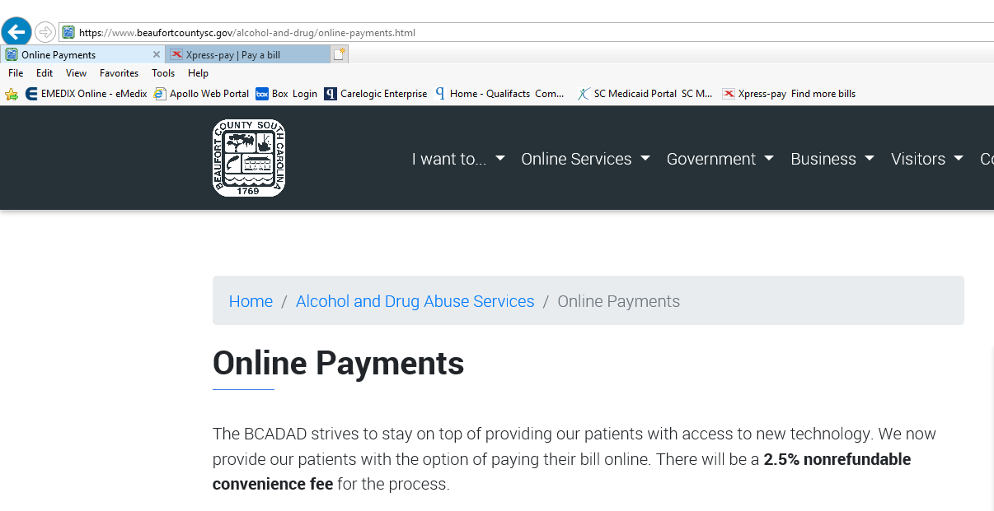
- If you agree to the terms, click on the button that says, “Pay Bill Online.”
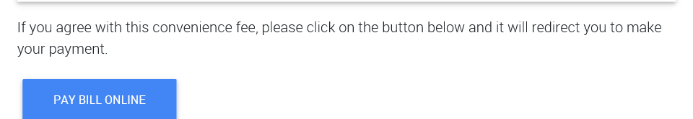
- A new window will pop up for BCADAD-Online Payments
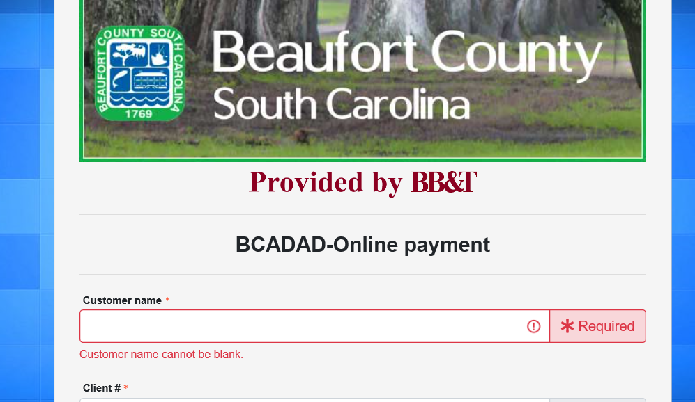
- Please enter information and follow instructions.
- Please make sure you print your receipt for your records. We will also send a receipt via snail mail once it is posted into your electronic record.
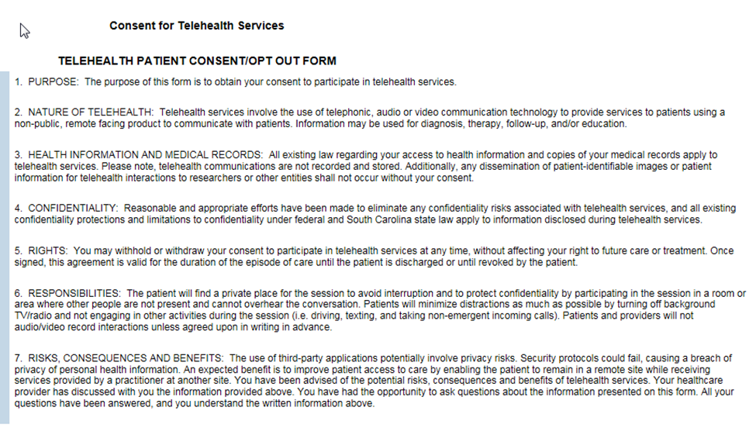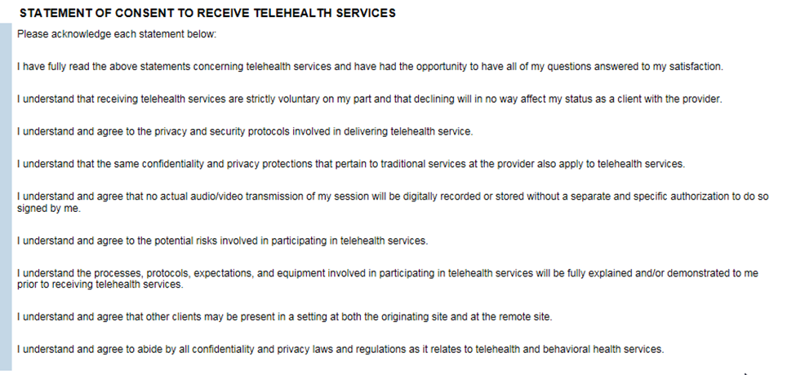
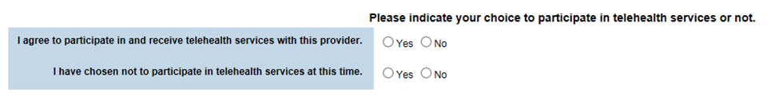Patient Signature and Date: ______________________________
Staff Signature and Date: ______________________________

